(1) PROJECT PROFILE
Project Title: Crafting Anti fungal Soap with pepperomia pellucida : A natural Cure for tinea versicolor Caused by malasezzia furfur
Name of Project Proponent: Rhimark S. Casimero, Samantha F De Castro, Princess Aliys L. Perez, Princess dianne F. Roco, Prince Gabriel A. Buniel, Dia Trexie A.
Marcelo
Region: CARAGA Division: Bislig City
School: Bislig City National High School Grade Level: 9
Project Duration (number of months): 3 months
Email: Emakcasimero@gmail.com Contact Number 639676377397

(2) CATEGORY OF RESEARCH  __Physical Science  / Life Science  __Robotics and Intelligent Machines  __Mathematics and Computational  Sciences  (3)  Individual  _/_Team | (4) THEME  __Food Safety  __Water Conservation  __Renewable Energy  __Cyber Security  __Traffic/Road Congestion  _/_Health  __Disaster Mitigation  Agriculture and Environment  __Others
(5) EXECUTIVE SUMMARY
This study aims to develop an antifungal soap using Peperomia pellucida extract as a natural and affordable treatment for tinea versicolor caused by Malassezia furfur. Tinea versicolor is a common superficial fungal infection in tropical regions, and conventional treatments may be expensive or cause skin irritation. The research will evaluate the antifungal activity of the plant extract incorporated into soap by testing its effectiveness against cultured fungal samples. Laboratory experimental methods will be used to measure fungal growth inhibition, and statistical analysis using a t-test will determine whether the plant-based soap has significant antifungal effects compared to a control treatment. The expected outcome is a safe, accessible, and effective natural antifungal product that may help reduce reliance on synthetic medications.

(6) INTRODUCTION
(6.1) Rationale
Skin infections such as tinea versicolor are common in tropical countries like the Philippines due to warm temperatures, humidity, and increased sweating. This condition affects many individuals and can cause discomfort, itching, and changes in skin pigmentation, which may affect self-confidence. Although antifungal medications are available, some people cannot afford them or may experience side effects. Because of this, there is a need to explore alternative treatments that are affordable, accessible, and safe.
Peperomia pellucida is a plant commonly found in local environments and has been traditionally used for medicinal purposes. It contains bioactive compounds that may possess antifungal and antimicrobial properties. This study aims to investigate whether Peperomia pellucida extract can be used as an ingredient in soap to help treat fungal infections, particularly tinea versicolor. The research also seeks to promote the use of natural resources available in the community.

(6.2) Research Questions
How effective is Peperomia pellucida as an antifungal ingredient in soap for treating tinea versicolor compared to commercial antifungal soaps?

(6.3) Research Hypothesis
Null Hypothesis (H₀):
There is no significant difference In the effectiveness of Peperomia pellucida soap and commercial antifungal soaps In treating tinea versicolor.

Alternative Hypothesis (H₁):
There is a significant difference In the effectiveness of Peperomia pellucida soap compared to commercial antifungal soaps in treating tinea versicolor.
(6.4) Scientific Basis
Tinea versicolor is a superficial fungal infection caused primarily by Malassezia furfur, a lipophilic yeast that normally exists on human skin but can become pathogenic under favorable environmental conditions such as heat and humidity. The infection commonly results in skin discoloration, scaling, and itching, especially in tropical countries where environmental conditions promote fungal growth (Genuino et al., 2024).
Although synthetic antifungal medications such as azoles are widely used, concerns regarding drug resistance, cost, and possible side effects have encouraged researchers to explore plant-based antifungal alternatives (Filip et al., 2010). Medicinal plants contain bioactive compounds including flavonoids, alkaloids, tannins, terpenoids, and phenolic

substances that exhibit antimicrobial and antifungal properties by disrupting fungal cell membranes and metabolic processes.
Several studies have demonstrated the effectiveness of plant extracts against Malassezia species. For example, aloe vera extract has been shown to significantly inhibit the growth of Malassezia furfur in vitro, with higher concentrations producing stronger antifungal activity (Nasution & Lubis, 2023). Similarly, ethanol extracts from various plants such as clove and ginger have shown inhibitory effects against cultured Malassezia furfur, confirming the potential of plant-derived antifungal agents for treating fungal skin infections.
(7) Objectives
To determine the antifungal effectiveness of Peperomia pellucida extract formulated into soap against cultured fungal samples associated with tinea versicolor.

Specific objectives:
1.To extract bioactive compounds from Peperomia pellucida for soap formulation.
2. culture fungal samples suspected to contain Malassezia furfur under laboratory conditions.
3.To evaluate antifungal activity by measuring fungal growth inhibition.
4.To compare the effectiveness of the experimental soap with the control treatment.
5.To determine significant differences using statistical analysis (t-test).
(8) REVIEW OF LITERATURE
Medicinal plants have long been recognized for their antimicrobial properties due to the presence of bioactive compounds such as phenolics, alkaloids, and essential oils (Cowan, 1999). These compounds are known to disrupt microbial cell membranes and inhibit microbial growth (Burt, 2004).

Peperomia pellucida has been widely studied for its pharmacological properties. Research by Idris et al. (2015) demonstrated that extracts of Peperomia pellucida exhibit antimicrobial activity against several microorganisms. Similarly, Sukri et al. (2025) reported that the plant contains significant phytochemical components that contribute to its medicinal value.
Pharmacological investigations also revealed antioxidant and anti-inflammatory properties of Peperomia pellucida, which may support its therapeutic use in treating infections and skin disorders (Teodhora et al., 2025). Another study identified antiinfective compounds from the plant that showed promising antimicrobial activity (Ngo et al., 2024).Fungal infections caused by Malassezia species are common worldwide and are associated with environmental factors such as humidity and oily skin (Prohic et al., 2016). These fungi are part of normal skin flora but can become pathogenic under certain conditions (Crespo-Erchiga & Florencio, 2006).
Topical delivery systems such as creams, gels, and soaps are commonly used to treat fungal infections because they allow direct contact between the active compound and the affected area (Gupta & Foley, 2015). Soap formulations containing plant extracts have been shown to possess antimicrobial properties and may serve as effective treatment alternatives (Bakkali et al., 2008).
(9) METHODOLOGY
• RESEARCH DESIGN - The study will use an experimental research design to evaluate the antifungal effectiveness of Peperomia pellucida extract formulated into soap against fungal cultures. The independent variable is the concentration of Peperomia pellucida extract incorporated into the soap, while the dependent variable is the antifungal

activity measured through the inhibition of fungal growth. A controlled laboratory setup will be used to compare the treated fungal samples with untreated control samples.
- RESEARCH INSTRUMENT - The materials and instruments to be used in this study include Peperomia pellucida plant samples, lye, oils, soap molds, beakers, stirring rods, gloves, masks, petri dishes, agar medium, incubator, sterile swabs, and measuring tools such as rulers or calipers for measuring fungal growth inhibition zones. Personal protective equipment (PPE) will be worn to ensure safety and prevent contamination during laboratory procedures.
- DATA GATHERING PROCEDURE - The researchers will collect Peperomia
pellucida plants from the local area and prepare the extract to be used in the soap formulation. The soap will be produced by mixing the plant extract with the prepared soap base and allowing it to cure for several weeks.. A fungal sample suspected to contain Malassezia furfur will be obtained and cultured using appropriate growth media in petri dishes under controlled laboratory conditions. After sufficient fungal growth is observed, the formulated soap will be applied to the cultured samples. A control group without treatment or with commercial antifungal soap may also be included for comparison. Observations will be recorded based on the inhibition of fungal growth over a specified period.
- DATA ANALYSIS - The antifungal effectiveness of the Peperomia pellucida soap will be analyzed by measuring the diameter of fungal growth inhibition zones in the treated and control samples. The collected data will be summarized using mean and standard deviation. A t-test will be used to determine whether there is a significant difference between the antifungal activity of the experimental soap and the control treatment. This statistical analysis will help identify if the plant-based soap has a significant antifungal effect.
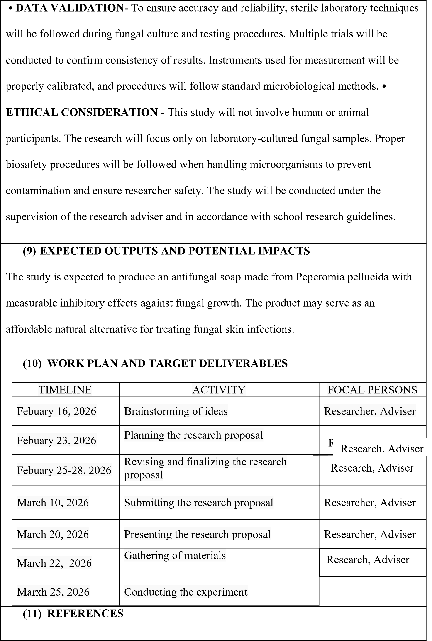

- Abadi, H., & Eulis, V. (2023). Formulation and activity tests of Peperomia pellucida extract shampoo against fungal growth. International Archives of Medical Sciences and Public Health
- Chau, T. T., & Men, T. T. (2024). Peperomia pellucida ingredients and antioxidant properties. Journal of Microbiology and
Biotechnology.https://www.ncbi.nlm.nih.gov/pmc/articles/PMC9147243/

- Idris, O. O., Olatunji, B. P., & Madufor, P. (2015). Antibacterial activity of Peperomia pellucida extracts. Microbiology Research Journal International.
- Indra, I., Aditya, P. Y., & Setiawan, F. (2024). Development of Peperomia pellucida gel mask. Pharmacoscript.

- Mukhlisa, I., Juwita, Z., & Dita, S. (2025). Effectiveness of Peperomia pellucida extract against bacteria. Journal of Health Science and Medical Therapy.
- Ngo, Q. M. T., et al. (2024). Anti-infective compounds from Peperomia pellucida.
Natural Product Research.
- Nazzaro, F., et al. (2013). Effects of essential oils on microorganisms. Pharmaceuticals.
- Hammer, K. A., et al. (1999). Antimicrobial activity of plant extracts. Journal of Applied Microbiology.
- Cowan, M. M. (1999). Plant products as antimicrobial agents. Clinical Microbiology Reviews.
- Bakkali, F., et al. (2008). Biological effects of plant essential oils. Food and Chemical Toxicology.

- Crespo-Erchiga, V., & Florencio, V. D. (2006). Malassezia yeasts and skin conditions.
Clinical Microbiology Reviews.
- Prohic, A., et al. (2016). Malassezia species and skin diseases. Clinical Dermatology.

- Prohic, A., et al. (2016). Malassezia species and skin diseases. Clinical Dermatology.

- Havlickova, B., et al. (2008). Epidemiology of fungal infections. Mycoses.

- Hay, R. J. (2017). Superficial fungal infections. The Lancet.

- Gupta, A. K., & Foley, K. A. (2015). Antifungal treatment of skin infections. Journal of Dermatological Treatment.

- Yamasi, D. H. A., et al. (2023). Cream formulation of Peperomia pellucida. Jurnal Kesehatan.

- Teodhora, T., et al. (2025). Pharmacological insights of Peperomia pellucida. Journal of Experimental Pharmacology.

- Sukri, M. A. M., et al. (2025). Comprehensive review of Peperomia pellucida.
Malaysian Journal of Applied Sciences.

20. Ogunmoye, A. O., et al. (2018). Antimicrobial activities of Peperomia pellucida essential oils. Journal of Chemical Society of Nigeria.

